IS739 INFORMATION SYSTEMS IN ORGANISATIONAL DESIGN AND APPLIED SYSTEMS THINKING

FINAL EXAM

Deadline 12 January 2020

Please e-mail me your reports to sevgiozkan2016@gmail.com and submit them online on odtuclass.

This take home exam will constitute 40% of your overall grade. Please be concise and write briefly with necessary amount of detail.

QUESTION: You are asked to take an "organization" to examine. This organization can be the one you work at or any other.

You will examine the organization following the 5-step approach in the book looking into the 15 sections beginning with "1. Organizational Goals, 2. Strategy, 3... etc. " (please see table 10.1 below).

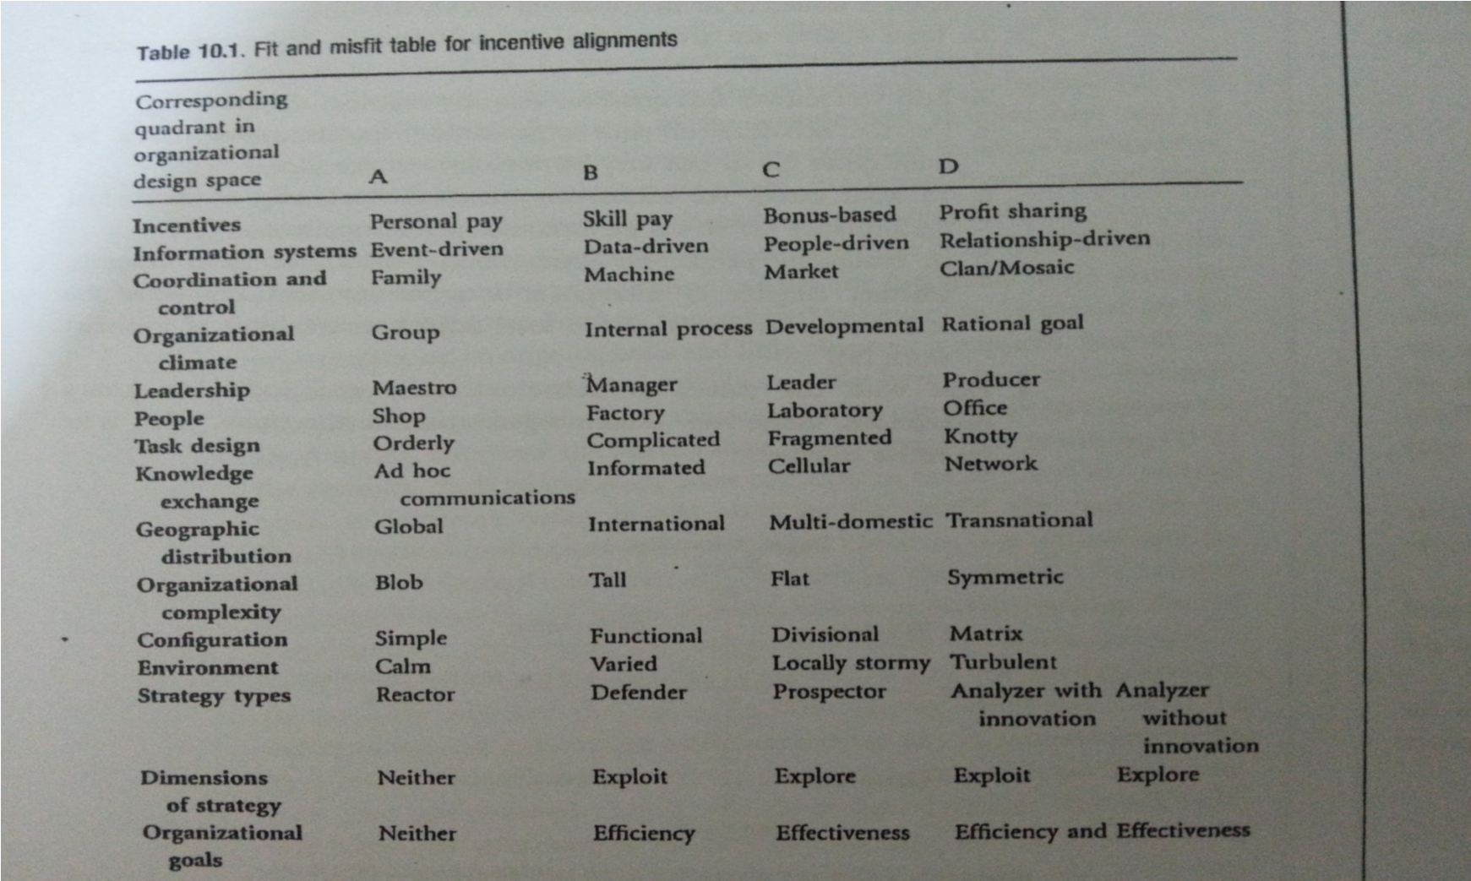

For each section, you are expected to allocate your organization in one of the four types (or quadrants) with necessary supporting discussion. You are expected to do this following the diagnostic questions given in the book at the end of each section/chapter.

If the organization does not fall into one particular type, then you may discuss the reasons for the misfit and give suggestions for the fit as given in the book in Chapter 11.

Finally, please present a full fit/misfit table for your organization.

There is no page limit however for each section one paragraph of about 150 words/ one third of a page is sufficient. Please state any assumptions you make. For example, if you considering one division of a large organization.